Shankarenfo Pannagiani Dharma, Gurpreet Kaur, Neha, John Ugonobo

Douglas college csis 4280  Course Group 4 Project

Tug-of-logic game project

**Abstract**:

A Tug-of-Logic game is a subjective game of debate, wherein debators must pick a side on selected CLAIM: For or Against. Debators then make STATEMENTS supporting their position or detracting the opposition. Each STATEMENT is argued/discussed upon in a single timed BOUT, which debators must live-vote on its truth value (TRUE/FALSE). The Judge can end this bout prematurely at any time. Once all statements have finished their BOUTS, a final vote is made on the CLAIM. After this, debators that have switched sides must now state their reasoning.

**Game: Tug of Logic**

-Multiplayer Game

-Players: 1 Judge (Instructor) & many Debators (Students)

**Features/Rationale**:

As a Judge:

* HOST a game by making a CLAIM.
* observe BOUTS
  + end them prematurely
  + ask questions during discussions
* reword the statements to fit discussion

As a Debator:

* Pick initial sides on CLAIM (For/Against)
* Create STATEMENTS regarding CLAIM.
* During BOUTS, discuss/debate regarding a CLAIM's truth.
* vote on a STATEMENT's legitimacy
* switch sides between BOUTS
* vote on CLAIM's legitimacy at final round
* cite their reasoning during closing

**Program Flow**:

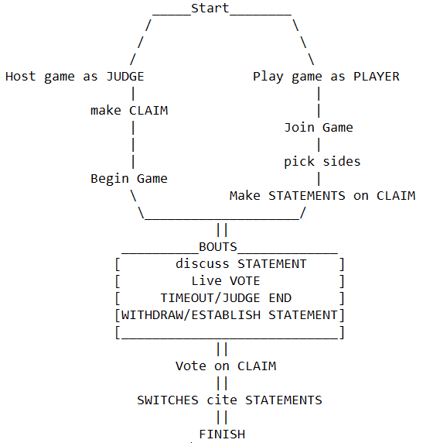

**Database Structure**:

**Interface**: